Name: Astha Arpit Bhatt

Enrollment: 196140316006

**Practical-18**

Develop a JSP program to display the grade of a student by accepting the marks of five subjects

Code: **File name: Index.html**

<html>

<head>

<title>TODO supply a title</title>

<meta charset="UTF-8">

<meta name="viewport" content="width=device-width, initial-scale=1.0">

</head>

<body>

<h1>Student Marks</h1>

<form action="marks.jsp" method="post">

Enter C: <input type="text" name="c"><br>

Enter JAVA: <input type="text" name="java"><br>

Enter KOTLIN: <input type="text" name="kotlin"><br>

Enter SWING: <input type="text" name="swing"><br>

Enter PYTHON: <input type="text" name="python"><br>

<input type="Submit">

</form>

</body>

</html>

**File name: marks.jsp**

<%@page contentType="text/html" pageEncoding="UTF-8"%>

<!DOCTYPE html>

<html>

<head>

<meta http-equiv="Content-Type" content="text/html; charset=UTF-8">

<title>JSP Page</title>

</head>

<body>

<%

int c = Integer.parseInt(request.getParameter("c"));

int java = Integer.parseInt(request.getParameter("java"));

int kotlin = Integer.parseInt(request.getParameter("kotlin"));

int swing = Integer.parseInt(request.getParameter("swing"));

int python = Integer.parseInt(request.getParameter("python"));

int total = c+java+kotlin+swing+python;

double avg = total/5;

if(avg>70)

out.println("Your grade is AA");

else if(avg>=65)

out.println("Your grade is AB");

else if(avg>=60)

out.println("Your grade is BB");

else if(avg>=55)

out.println("Your grade is BC");

else if(avg>=50)

out.println("Your grade is CC");

%>

</body>

</html>

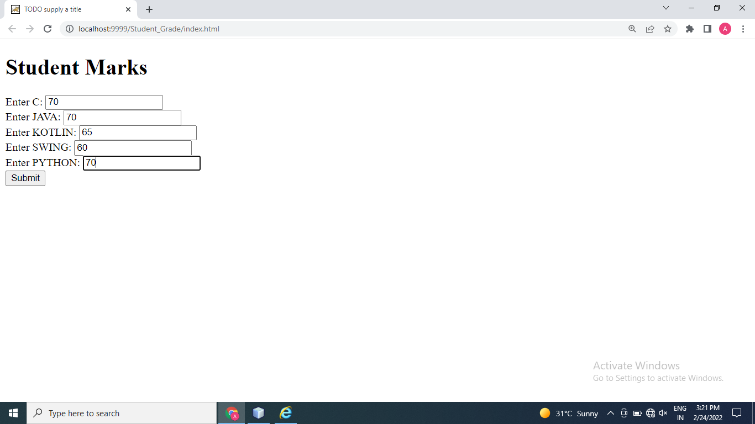

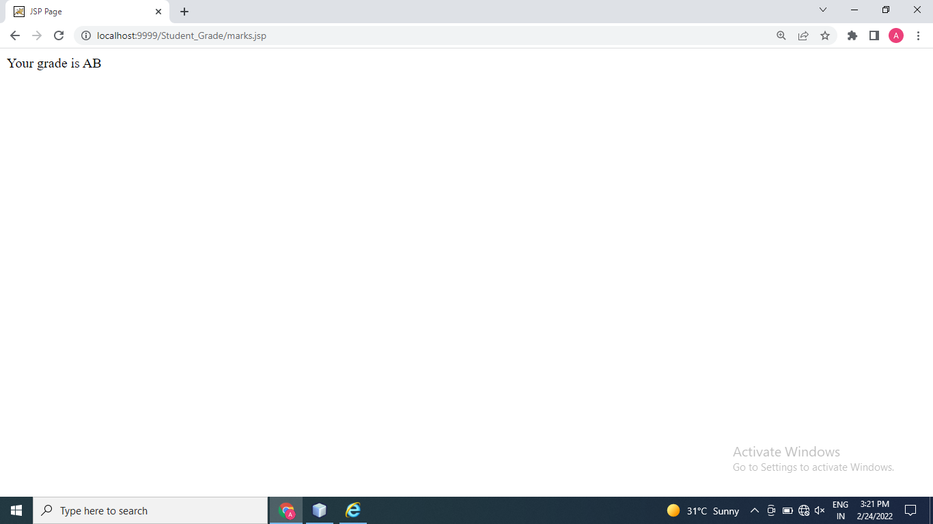

Thanks mam!!